**Delegate Details**

Room Choice  Single Occupancy  Double Occupancy

# Delegate 1

Name

Company Name

Email Mobile

# Delegate 2 in the Double Occupancy Room (if applicable) (Can be Filled Later)

Name

Company

Email Mobile

# Billing Details

Company Name

Address

City State

Country

GST Number

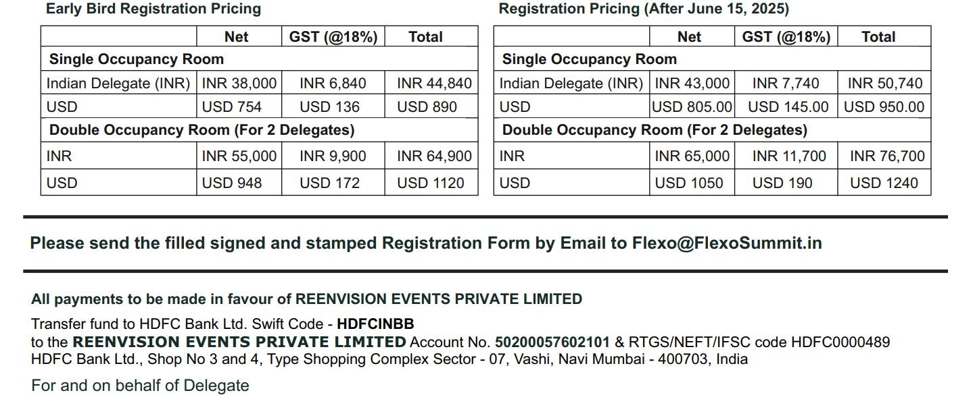

Name:

Company Stamp & Authorised Signature Date: